
10 Summer Safety Tips for Seniors

Moravian Messenger

What did the flag do when it lost its voice?
It just Waved.
1: Hydrate, Hydrate, Hydrate
*Drink more and know the signs of Dehydration
2: Wear Proper Sun Protection
*Use Sunscreen of SPF 30 or more

3: Dress Right

*Lightweight Clothing

4: Avoid Going Out in High Temperatures
*High heat and humidity can mean risky business for seniors

5: Know the Signs of Heat Exhaustion and Heat Stroke
*Red or flushed skin, Rapid heartbeat, tiredness, Headache, Confusion, Weakness

6: Know Your Medication Interactions *Some medications may cause your body to be more sensitive to the sun.

7: Keep It Cool *Keep you & loved one’s home cool by letting the air conditioning run, especially as temperatures reach 90°F and above.

8: Prevent Trips and Falls *Outdoor rugs, pool decks, sandy shores, and even uneven patio flooring can quickly become a safety hazard.

9: Check in With Loved Ones *Check in with your loved ones regularly throughout the summer. Learn more about their daily activities, encourage them to drink water regularly, ensure their air conditioning units are working, and help them limit their exposure to the sun. 10: Always Consult A Doctor *Before summer heats up and the activities begin, you or your loved one should consult a doctor. Find out if there are any limitations they recommend or learn about any concerns they may have.
For the month of July, the Senior Center Kitchen will be Selling a Variety of Drinks every Thursdays of the month!!!
See below for monthly menu: $3.00 Each.

July 9th - Piña Colada

July 16th - Strawberry Margarita

July 16th ⁻ Bahama Mama

July 23rd - Summer Sunrise
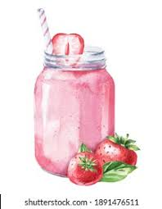

July 2026
Moravian House Apartments
701 & 737 Main Street
133 W. Union Blvd.
70 W.North St.
Bethlehem, PA 18018
Phone: 610-691-8409
Fax: (610) 936-9379




Who has to work on 4th of July?

-Fireworks

Where was the declaration of independence signed?

-At the bottom

What did the lightening say to the fireworks?

-You stole my Thunder!

What do ducks love about the 4th of July?
Fire Quackers.

What did the firecracker eat at the movies?
Pop Corn.

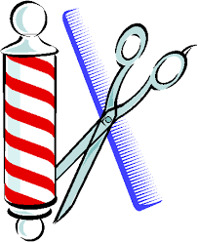
MEN & WOMENS HAIRCUTS

To schedule an appointment, Call Joiel at
610-984-4165
Please wash your hair prior to the appointment.
If you need to cancel your appointment, please call ahead of time.
Up Coming Events in the Valley!

Celebrate America’s 250th birthday with the biggest sky show the Lehigh Valley has ever seen!
On July 3rd, 2026, the Lehigh Valley IronPigs will host Liberty Ignited at Coca-Cola Park — featuring at least 250 drones lighting up the night sky in a choreographed show set to music. Expect bold patriotic imagery, creative designs, and moments you won’t want to miss.
The drone performance will be followed by the largest fireworks display in Coca-Cola Park’s history, combining for the most expansive skyward celebration ever staged in the Lehigh Valley.

It's the 39th Annual Blueberry Festival - where tongues turn blue - July 18 & 19, 2026! It’s the sweetest festival of the summer…and you’re invited! Make a plan to visit Bethlehem’s beautiful Burnside Plantation for great food; live music; fresh, delicious blueberries and desserts, Colonial cooking, gardening; kids activities; and much more!

Tenant’s Association Meeting

When?: Friday, July 17th
Where? Senior Center
Time?: 6PM

CENTRAL MORAVIAN FOOD BAGS

The food bags are delivered on the 4th Wednesday of the month at 12:00pm in the Senior Center. If you are interested in signing up for the food bags, please see Zuheidy. If there are items in the bag that you do not want, please put them in the free table in the Senior Center.
Do not leave them in common areas!

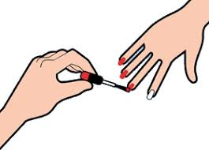
MANICURES

Manicure appointments can be made by calling Michelle at 484-951-0524.


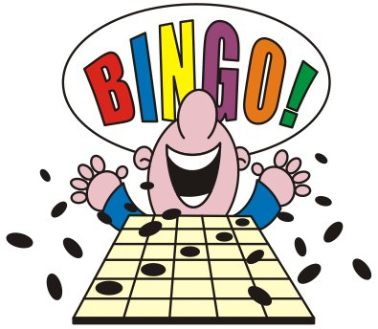
MH3
Gilberto M- 7/11
Esther R- 7/24
Judy G- 7/29
Nancy F- 7/31

MH1
Bernard A- 7/6
Monica D- 7/10
Cynthia S- 7/12
Diane B- 7/18
Joyce M- 7/19
Liza A- 7/19
Joe C- 7/19
Irene S- 7/20
Michael S- 7/22
Pamela S- 7/2

MH2
Carol L- 7/4
Gladine F- 7/5
Carl N- 7/8
Joanne S- 7/16
Patricia H- 7/20
Betty B- 7/21
Elaine O- 7/22
James G- 7/23
Cecilia I- 7/28
Trudy F- 7/29
Carmen A- 7/29

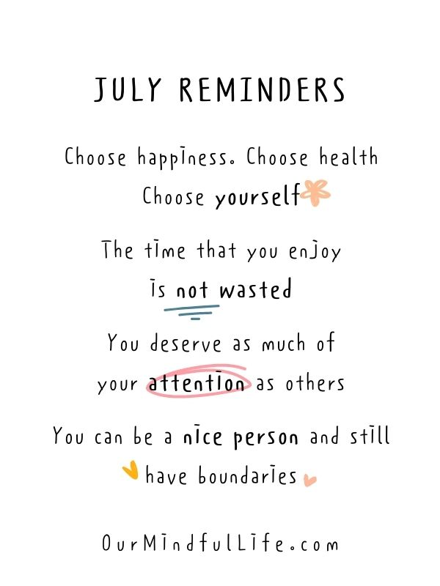

Bingo Every Thursdays at 5:00 PM
EVERYONE IS WELCOME

Health Network
Lab-Work
Weds. July 8th & 22nd

Health Network Lab is drawing blood in the Health-check office in Bldg. 1 at 7:30 am. It is first come, first served. The Lab Technician will be leaving when they finish with the last client signed in. Please be there by 7:30 am to sign-in. They will NOT wait for anyone. Please have your script for the bloodwork ready, and make sure you have followed the instruction on the lab slip.
RESET
When you have a million things that need to get done right away; or when the “To Do list” seems as though it is never ending; or when life throws a lot of curves at you and it is just easier to curl up in a ball and forget about everything – you need a reset!! You can’t always control what is going on in your life, but you can control how you respond to it. Here are a few things that you can do that are simple and can calm you and hopefully clear your mind for a bit:
· Change up how you talk to yourself: Instead of telling yourself, “I can’t handle this!” or “I shouldn’t feel this way!” Tell yourself, “You can feel overwhelmed” or “you don’t have to fix everything right away.” This changes the dialogue in your head so instead of being critical about yourself you are coaching yourself.
· Change your body temperature: Literally, splash some cold water on your face for about 20 to 30 seconds or rub an ice cube on your cheek or inner wrists. This will affect your nervous system and help you relax.
· Do some tapping: Tap both sides of your body at the same time. Utilize the butterfly hug. Face both palms toward you and twirl your thumbs together and spread your fingers out. With your intertwined thumbs on your collarbone and hands on chest, tap your fingers on theft and then on your right. Left, right. Slowly. This sends signals to your brain which help you to feel grounded or calm. (Real Simple April/May 2026)
Try it. See if anything works for you. When all else fails, 3 deep breaths in through the nose, out through the mouth, is effective as well.
~Kristel

