

Moravian Messenger

Thank You to all St. Patties Senior Center Winners!

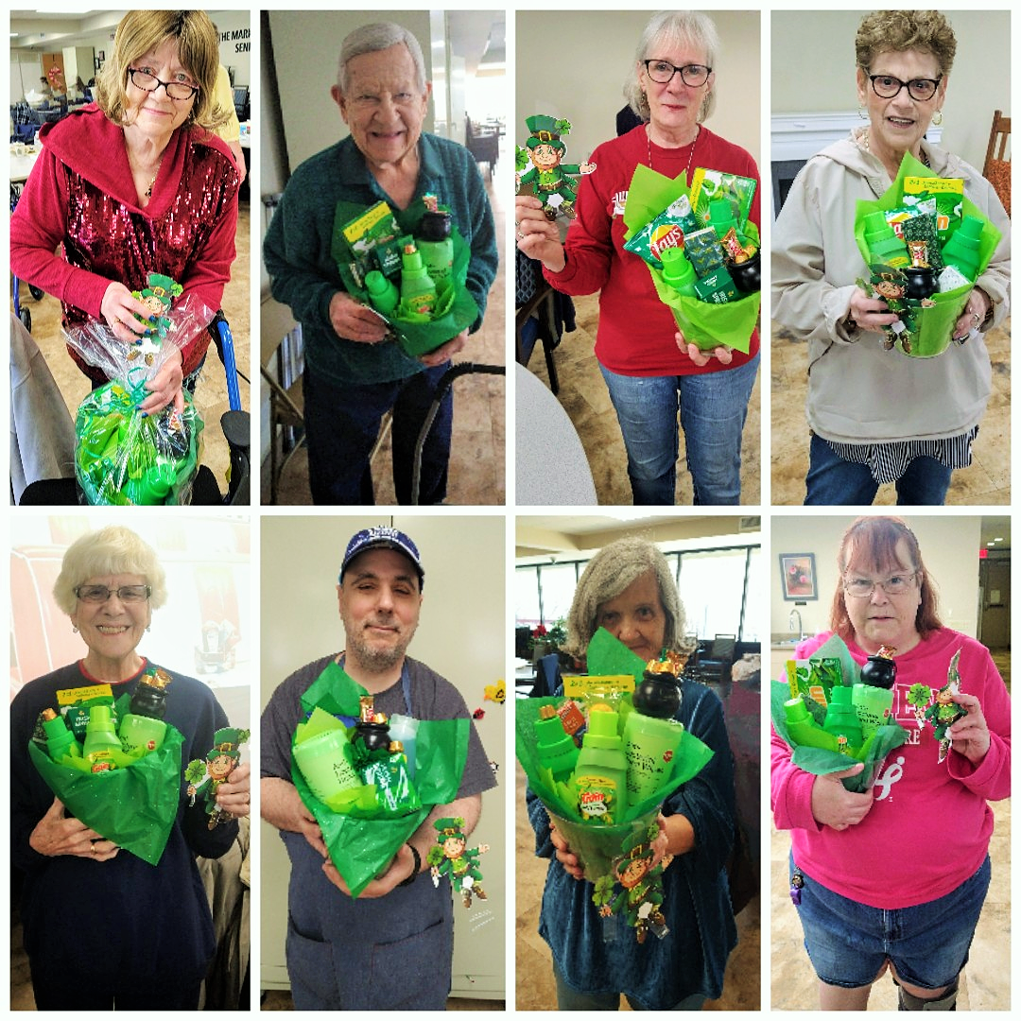


April 2025

Now that we’ve lost all our winter weight. All we are left with now are our Spring rolls.

Its allergy season again?!
You’ve got to be pollen my leg.

Why do eggs like April Fool’s Day?

They like practical yolks.

An Apple a day keeps the doctor away.

If you throw it hard enough.

Moravian House Apartments
701 & 737 Main Street
133 W. Union Blvd
70 W. North St.
Bethlehem, PA 18018
Phone: 610-691-8409
Fax: 610-936-9379



Why shouldn’t you tell an easter egg a joke?
They might crack up.

Why did the old man fall into the well?
Because he couldn’t see that well.

What falls but never gets hurt?
The rain

4 Spring Wellness Tips for Older Adults

PUT A SPRING IN YOUR STEP
Walking is one of the best low-impact activities for older adults, and it’s even more enjoyable in the springtime! If it’s been a while since you last exercised, be sure to ease into a regular walking routine slowly. Doing some simple sit-to-stand chair exercises can help you warm up before getting your steps in.

SOAK UP THE SUNSHINE (SAFELY)
Sunshine is a wonderful thing—it’s a natural source of Vitamin D, which provides mood-boosting benefits and even helps to strengthen our bones and immune health. However, we all need to be mindful about soaking up the sunshine safely. The risk of skin cancer increases as we age, and our skin becomes thinner and more sensitive to the sun. Be sure to wear sunscreen and cover up with a hat and sunglasses when you head outdoors. If you want to prevent prolonged sun exposure, try to plan outdoor activities in the early morning or evening to avoid the strongest rays.

PREPARE FOR SEASONAL ALLERGIES
Allergies can develop at any age, so be aware of common symptoms such as sneezing, runny nose, congestion, and itchy and watery eyes. If you or a loved one experiences these symptoms, talk to your doctor before reaching for over-the-counter allergy medications.

STAY HYDRATED
As the weather heats up and we spend more time in the sun, it’s important to have drinking water readily available. Older adults can get dehydrated easily because the sensation of thirst declines with age. If you or a loved one is having trouble drinking enough water throughout the day, try adding flavor to water with fresh fruit or eat more water-rich foods such as cucumber, tomatoes, and watermelon.

Manager’s Memo
April 2025

Offices and Senior Center Closed
The offices and Senior Center will be closing early on Thursday, April 17th and will be closed on Friday, April 18th in observance of Good Friday.

T.V. Cable
Reminder - April 1st the cable fee is $39.00.

Work Orders
ALL work orders MUST go through the offices. Maintenance cannot take work orders. Please call the office 610-691-8409.

Tenants with Pets/Service Animals
Please remember to keep your pet and service animal inoculations up to date. The office must retain these records in tenant files.

Loading Dock - MHI & MHII
The loading docks in MHI & MHII are for authorized personnel ONLY. Tenants are NOT permitted in these areas unless authorized by a member of management.

MHI Hallway Floors
This is an ongoing project throughout 2025. Management and staff want to thank our Tenants in advance for their cooperation and understanding during this time.

Renter’s Insurance
If anyone is interested in obtaining renter’s insurance or learning more about it, please come to the office in your building and get a brochure for “ERenterPlan”. They also have a website where you will put in your zip code and then choose the Moravian House that you live in to get an accurate quote: www.erenterplan.com. There are many affordable options to fit your needs. Moravian House is not affiliated with “ERenterPlan” in any way.

S T R E S S E D O U T!
“I’m so stressed out!”
Have you ever said this before? Have you ever felt this before? Chances are, you have answered “yes” to both. Everyone experiences stress from time to time, day to day. There are many stressors like work, finances, illness, relationships, natural disasters, world issues, aging, death of a loved one or friend. All of this can be overwhelming and can leave you feeling frazzled.
April is “National Stress Awareness Month.” According to the National Institutes of Health, “stress is a physical and emotional reaction that people experience as they encounter challenges in life.” Believe it or not, stress is not inherently bad for you, but rather it is your body’s way of guarding you. It can help you stay alert and energetic, and in an emergency, give you additional strength to defend yourself. The stress response when activated releases a stress hormone like cortisol and adrenaline. These hormones may have both a short and long-term effect on your body and brain. (4/2023 Vail Health Foundation)
The American Psychological Association states, “Stress is a normal part of life that can help us learn and grow.” However, chronic or excessive stress can negatively affect a person’s physical and mental health. So, what can you do to manage stress? Here are several things that may be helpful to you as you manage stressful situations, life changes, day-to-day things:
Exercise – your body releases endorphins when you exercise which help improve your mood and promote better sleep.
Sleep – have a consistent sleep schedule wherever possible and create a sleep conducive environment, which means turn of electronics, TV, etc., and sleep in a cool, dark space.
Mindfulness meditation – meditation helps by reducing symptoms of stress and anxiety and helps your mind focus on the present.
Time management – prioritize you tasks and utilize your time effectively, like setting realistic goals, breaking tasks into manageable chunks.
Social support – surround yourself with people who are positive influences in your life not negative; people who make you feel good about yourself; people who make you smile and bring joy to your life. (4/2023 Vail Health Foundation)
Sometimes, just taking the time to “smell the roses,” is what you need as well. Essential oils like lavender, peppermint, grapefruit, lemon can help reduce stress by just inhaling of the wonderful aroma. Remember to be kind to yourself. If you ever need to talk with me, I am a phone call away.
Kristel

Podiatry Appointments

Dr. Lori Proctor
610-437-9343

For appointments, call Directly Doctors office.
Lab-Work
Wednesday,
April 2nd, 16th, 30th

Health Network Lab will be drawing blood in the HealthCheck office in Bldg.1 starting at 7:30 am. It is a first come-first serve, and the lab technician will be leaving when they finish with the last sign in.
Please try to be there by 7:30 am and remember to sign-in. They will not wait for anyone.


SECOND HARVEST
Second Harvest delivery schedule will be on the FIRST Thursday of the month. They will be delivered to your door going forward so make sure you make arrangements to be there.
Please make sure you have your correct apartment number and building on file with Zuheidy.
April Birthdays

CENTRAL MORAVIAN FOOD BAGS

The food bags are delivered on the 4th Wednesday of the month at 12:00 – 2:00 in the Senior Center. If you are interested in signing up for the food bags, please see Zuheidy. If there are items in the bag that you do not want, please bring them to the free table.
Do not leave them in common areas!

April is Stress awarness month

COMBATTING STRESS IN SENIORS
- Exercise and Physical Activity: Engaging in regular exercise can help reduce stress levels and improve mood. Seniors can consider activities such as walking, swimming, yoga
- Social Engagement: Maintaining social connections is vital for seniors’ mental well-being. Strengthening relationships with family and friends, joining community groups or clubs, or participating in volunteer work are all excellent ways to combat stress and enhance social support networks.
- Practicing Relaxation Techniques: Encouraging seniors to practice relaxation techniques such as deep breathing exercises, meditation, or engaging in hobbies they enjoy can be extremely beneficial.
- Seeking Support: Encouraging seniors to reach out for support is crucial. Whether it is a trusted friend, family member, or professional counselor, having someone to talk to can provide an outlet for stress management and assist in finding effective coping strategies.
- Maintaining a Balanced Lifestyle: Establishing a well-rounded routine that includes healthy eating habits, regular sleep patterns, and time for leisure activities.
- Utilize Technology: Introducing seniors to technology can offer them opportunities for stress reduction.
- Prioritizing Self-Care: Self-care is crucial for managing stress in seniors. Encourage them to prioritize their own needs and engage in activities that bring them joy and relaxation. This can include taking a warm bath, reading a book, listening to soothing music, or indulging in a favorite hobby.
- Eating a Healthy Diet: A well-balanced diet plays a significant role in managing stress levels. Encourage seniors to consume nutritious foods that support mental and physical health. Foods rich in antioxidants, such as fruits and vegetables, can help combat the negative effects of stress on the body.
- Engaging in Mindfulness Activities: Mindfulness practices can be highly effective in managing stress. Seniors can benefit from activities such as mindful breathing, guided imagery, or journaling.
- Getting Sufficient Rest: Adequate sleep is essential for managing stress and promoting overall well-being. Encourage seniors to establish a regular sleep schedule and create a relaxing bedtime routine to improve sleep quality. Promoting a comfortable sleep environment and avoiding stimulating activities close to bedtime will help seniors achieve better rest and wake up feeling refreshed.
- Supporting Emotional Well-being: It’s important to acknowledge the emotional aspect of stress in seniors. Encourage them to express and manage their emotions in healthy ways, whether through talking with a supportive friend or family member, engaging in creative outlets such as painting or writing, or seeking professional counseling if needed. Assure seniors that their emotions are valid and that there are resources available to help.
- Practicing Time Management: Seniors often have various commitments and responsibilities. Teaching them effective time management skills can reduce stress and increase productivity. Promote the use of calendars, to-do lists, or digital reminders to help seniors stay organized and prioritize tasks. Breaking down larger tasks into smaller, more manageable steps can alleviate feelings of overwhelm and promote a sense of accomplishment.

MHI
Maribeth M- 4/1
Michael C- 4/5
Dennis K- 4/8
Alice L- 4/10
Mary D- 4/11
Nancy C- 4/13
William B- 4/14
Sandra S- 4/19
Bernard O- 4/20
Ilona M- 4/24
Richard P- 4/24
Troy H- 4/28
Joaquim S- 4/29
William B- 4/30

MHII
Felix R- 4/1
Chris B- 4/7
Juan M- 4/16
Ligia M- 4/17
Nereida C- 4/19
Nancy M- 4/19
Lenwood L- 4/27
Pedro T- 4/29

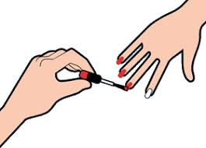


MANICURES

Manicure appointments can be made by calling Michelle.
484-951-0524
MEN & WOMENS HAIRCUTS

Call ahead to make an appointment.
610-984-4165

Please wash your hair prior to
your appointment. If you need to cancel, your appointment, please call ahead of time so that
someone else can take your spot...

Win Cash Prizes
Thursdays @ 5:00

Kick-Off Spring With The New Walking Club!

With the weather getting warmer out, it’s a good time to start walking. There are several people who are looking for others to walk with. Sign-up in the Senior Center to join the walking club. Every Wednesday we will meet at the Senior Center at 1:00, weather permitting. Please make sure to wear sensible shoes, bring a jacket, sunscreen, and a bottle of water.
Start Date: 4-2-25.

MHIII
Rosemarie G- 4/4
Hector V- 4/28

RELIGIOUS ACTIVITIES

CHURCH SERVICE: Fridays at 9:45

Bible Study:

Tuesdays at 5:00

Wednesdays at 2:00

(Chapel)

